Mite Report 2014

Introduction
Our research program has grown in many ways since last year. Unlike last year, we have some strong statements to make from the data we have collected. The amount of data received this year has increased massively, when compared to last year. I want to be clear that this would not have been possible without the help of the many beekeepers that helped. This is OUR data, thank you for making it more informative. Of course, we will still need more data, but that is the nature of things.
After last year’s attempt to establish baselines of untreated colonies, we ended the year wanting to continue to evaluate the effectiveness of the sampling protocol and establish more effectiveness of the method. To this end, we have succeeded and surpassed our goals.
Our conclusions and goals for this year are summarized at the end of this report.

Methods
We continue to use “live drops” this year to monitor mites; this involves counting mites that drop from colonies onto sliding trays, most often through a screened bottom board. Throughout the report we call the counts of a live drop “mite counts” and “samples.” We want to emphasize that not only is this live drop proving to be effective and informative, but it is non-lethal and can be performed at any time of the year, even when the honeybees are in their winter cluster. This allows us insight into the health of colonies and general mite populations that we can’t obtain any other way.
With the support of Green River Community College, we were able to provide, for free, 10 bottom boards for research participants this year. The sole purpose of this was to increase our number of hive samples from beekeepers who did not have a screened bottom board. We received mite counts from 7 of these 10 bottom boards.
We also supplied to research participants 18 Mite Away Quick Strips (MAQs), at no cost, for testing the effectiveness of using “live drops” vs. the effectiveness of the MAQs. We are displeased to note that we only received data from 3 of those 18 MAQs recipients and will seek ways to improve adherence to program protocols (or recoup expenses of materials) in these cases in the future.
We have also asked beekeepers to take photographs of the sliding trays before they count the mites. To this end, we have approximately 200 photographs. We were not able to analyze these photographs this year, but plan to use computer analysis to determine pollen colors throughout the years. We will continue to stockpile these photographs until such computer analysis is available; should you be willing to help in this regard, please see the “how you can participate” section at the end of this report.

Results
This year we received counts from beekeepers (instead of having the material sent to us) and did not analyze any material under the microscope. We expect this is the reason why we were able to collect much more data. Specifically, we received 638 samples (81 in 2013) from 26 hives (8 in 2013) for a total of 62994 mites counted (11,453 in 2013). Figure 1 represents the same information, graphically.
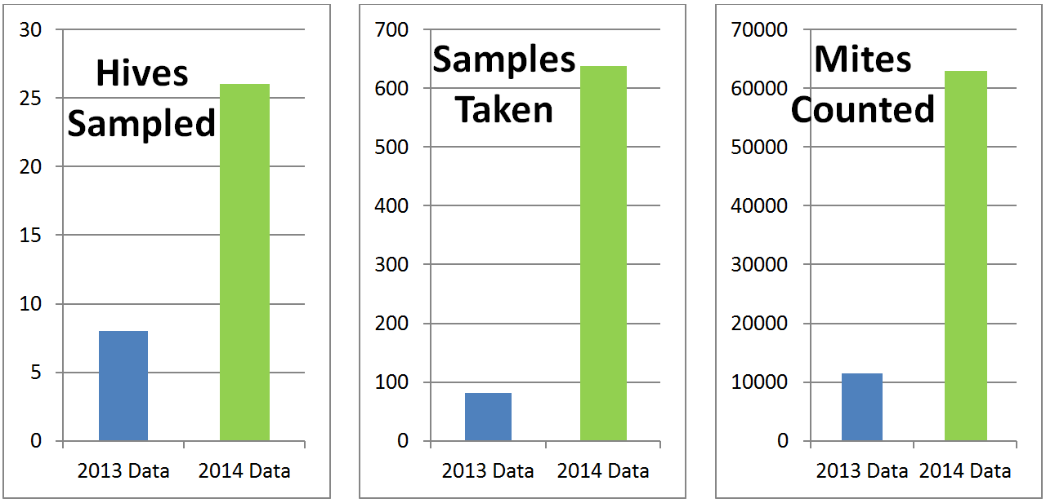
FIGURE 1 – Data collection statistics copmparing 2013 and 2014

In order to make all the data comparable we had to transform it from raw counts (numbers of mites), to counts per day by dividing the raw counts by the duration. Below are specific results.

Baselines – Treatment Free Beekeeping
We consider any colony as relevant for “Baselines” if it has not been treated for mites (MAQs, Hopguard, etc.) that year. Once it has been treated for mites, it is treated as a treated colony should be treated ; aka, it is no longer a baseline. We have two relevant analyses from our baseline data: updated baselines per month, analysis of live drop duration.
UPDATED BASELINES PER MONTH
As of now, we are not differentiating between any specific beekeeping practice, manipulation, or technique; we simply do not have enough data. Thus, the baselines represent “what treatment free beekeepers do generally”. 5 colonies contributed to baselines this year, providing 138 mite counts. When combined with last year, we have a total of 13 total colonies providing 213 mite counts. The graphs are in figure 2.
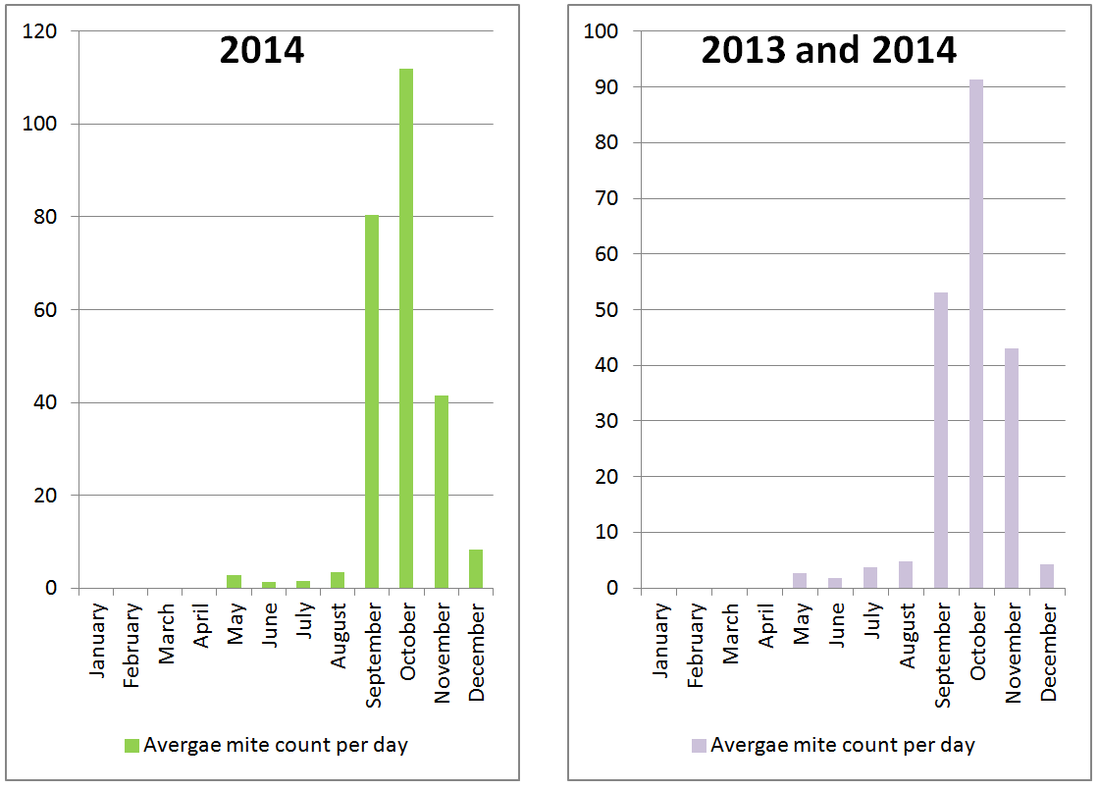
FIGURE 2 – Baseline data of treatment free colonies by month for 2014 and combining 2013 and 2014. No method of treatment free beekeeping practices is implied here.

We now have enough data to get some analysis of variance. Combining the two data sets and adding the 95% confidence intervals gives us figure 3. The 95% confidence interval represents the idea that if we were to resample the colonies 100 times, the average mite count per day would fall in that interval 95 of those 100 times. The numbers below the months represent the number of samples (n) for each month. Remember, these represent baselines with no treatments, generally. We will refrain from speculating as to WHY we have the two conclusions below to make sure we don’t overstate our understanding.
1. In September, October, and November more mites drop than the other months studied.
2. May, June, July, August, and December are similar in their mite drops.
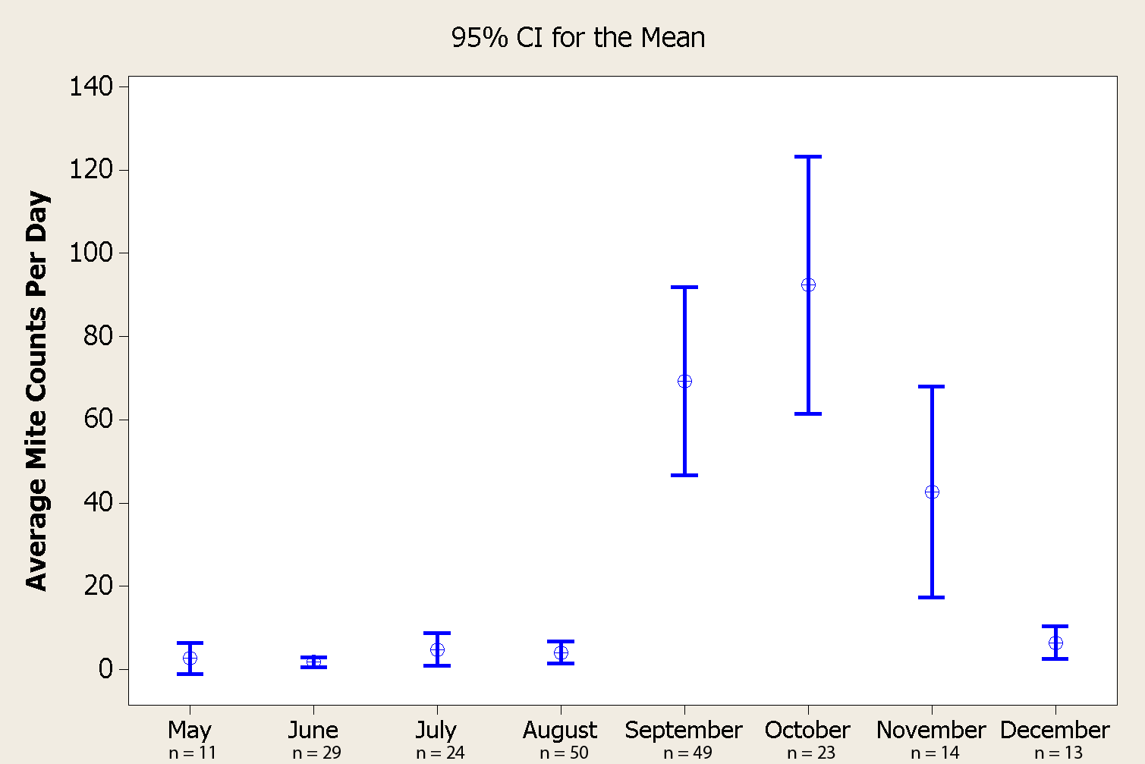
FIGURE 3 – Baseline mite counts for treatment free colonies by month with the 95% confidence intervals.

ANALYSIS OF LIVE DROP DURATION
In 2013 there seemed to be a difference between 1 day counts and 6 day counts. We clearly did not have the data to verify that, but this year had some more. We sub-sampled the baselines by looking at the May-August (MJJA) time period (more consistent live drops, with less variation) and the September-November (SON) time period (less consistent live drops, with more variation). Figure 4 shows the 95% confidence intervals for the 1, 6, and 7 day durations in those two time periods. We have two conclusions.
1. It does not matter what the duration is for those low mite drop months (May, June, July, and August).
2. The one day counts (mites per day) are clearly higher than the 6 or 7 day counts over the high mite drop months (September, October, November), indicating that the average of the mite counts depreciate over time.
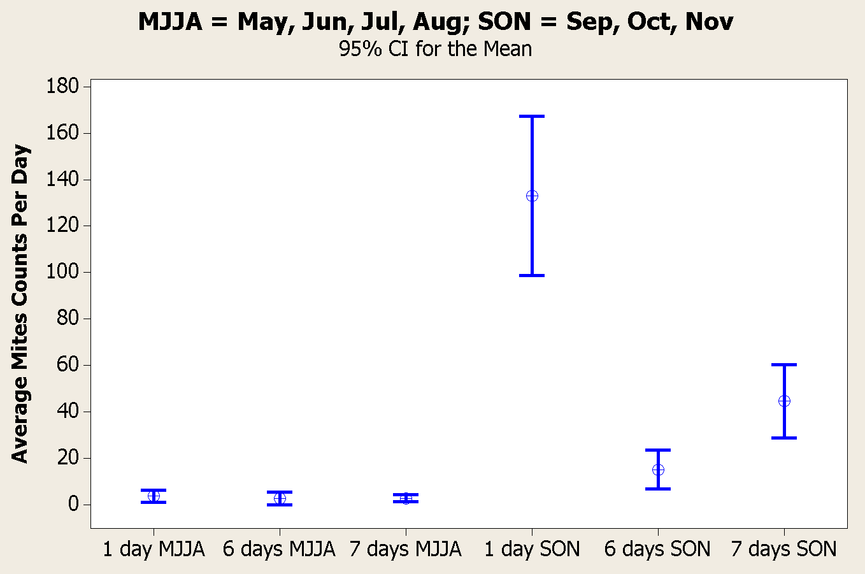
FIGURE 4 – Live drop duration analysis for 1, 6 , and 7 day durations. MMJA = the months of March, June, July and August. SON = the months of September, October, and November. 95% confidence intervals are included.

Treated Colonies
In 2013 we noticed a few colonies that were treated for mites and there was an immediate and drastic increase in the mite counts. This year we wanted to know if the “live drops” would be able to measure the effects of specific treatments. Unfortunately, we did not end up with enough data for any one particular treatment (MAQs, 1/2 MAQs, or Hopguard), so we lump them all together for now. 22 colonies were designated as treated at some point in 2014 and provided 506 samples; 1 queen was lost during MAQs treatment. We have two relevant analyses here: Duration of the immediate effect of treatments and the Effect of treatment 15 days after treatment.
DURATION OF THE IMMEDIATE EFFECT OF TREATMENTS
To analyze the duration of the effect of treatments on “live drops”, mites were counted the day of treatment, but before treatment; this is time 0. Then, the mites were sampled at after treatment, typically in one day intervals. Figure 5 displays the results from this analysis. Based upon the data, we have two conclusions to make.
1. It takes roughly 12 to 15 days to return to the original measure of live drops.
2. The initial and drastic increase (between time 0 and time 1) is also quite clear.
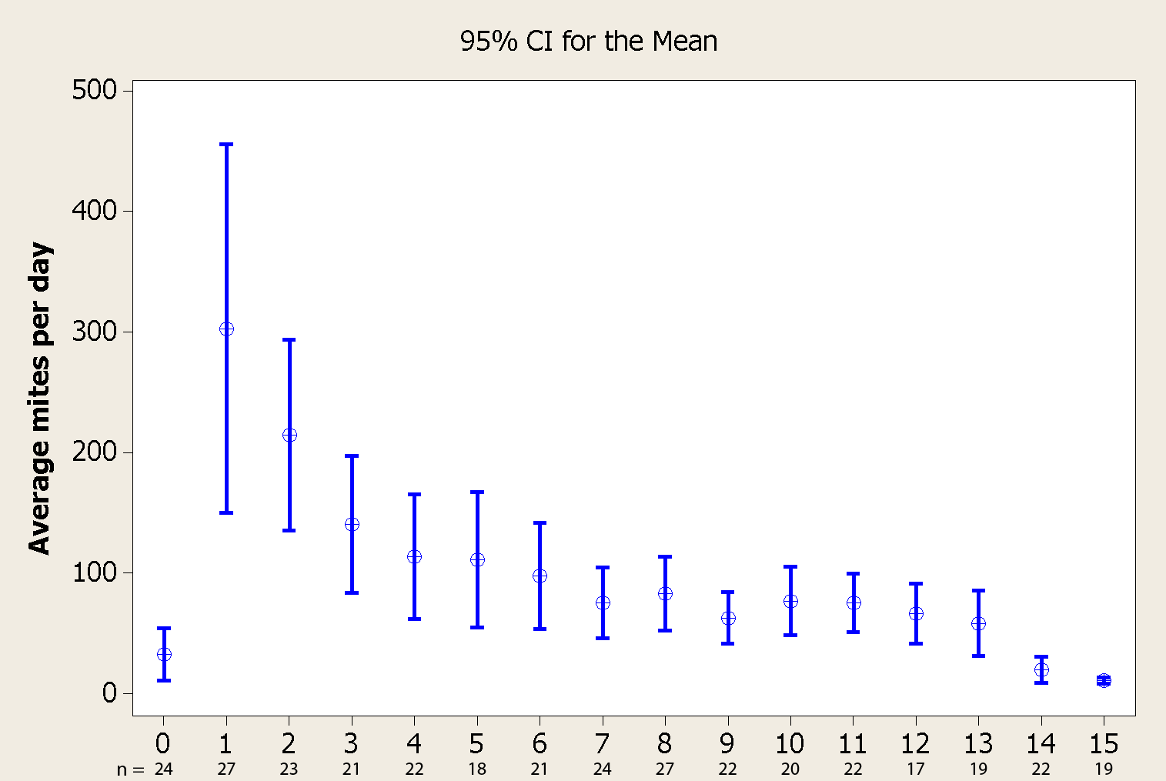
FIGURE 5 – Immediate effect of treatments (MAQs, ½ MAQs, and Hopguard together) based upon the day treated (Time 0) and the resulting 15 days after; with the 95% confidence intervals.

EFFECT OF TREATMENT 15 DAYS AFTER TREATMENT
Given the data in figure 5, we wanted to know what happens after a colony has been treated and is past the 12-15 days. This gives us a sense of the long term effects of treatment and allows us to compare the mite counts of baselines (treatment free) to treated colonies. If the mite treatment is effective, it should show a marked decrease in mite counts compared to the baselines (fewer mites in the colony to fall) if the “live drops” scale with mite population size. Figure 6 shows just that. The purple bars represent the 2013 and 2014 BASELINE data as shown in figure 2 and figure 3. The orange bars represent the mite counts of treated colonies, but ONLY the mite counts that were 15 or more days after a treatment had been applied.

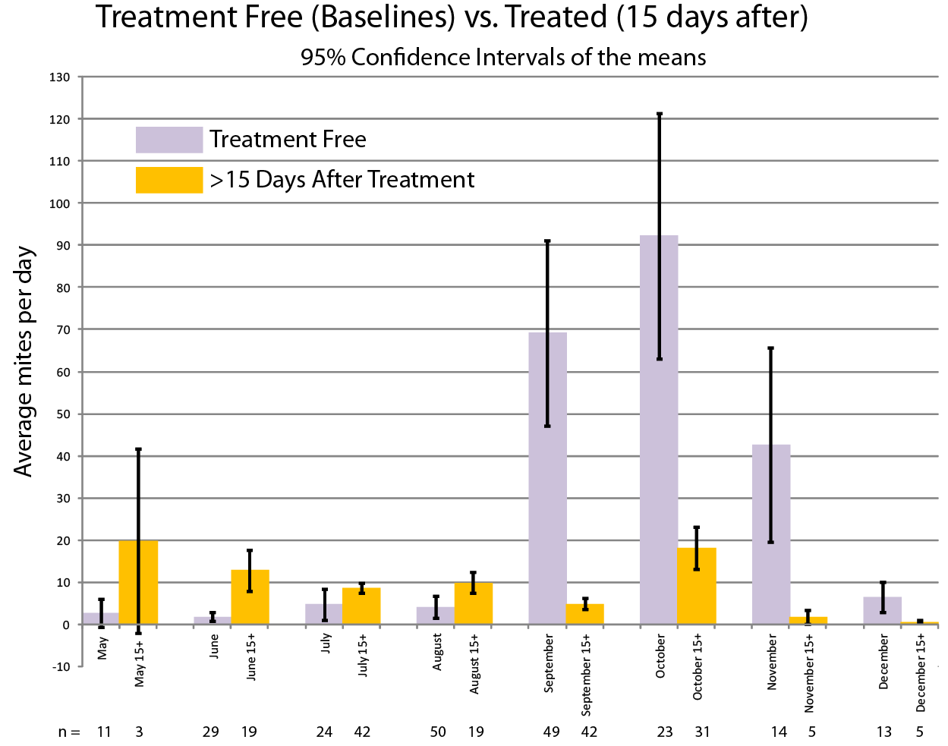
FIGURE 6 – Comparison of Treatment Free and Treated colonies (using only mite counts after 15 days past treatment) by month; with the 95% confidence intervals.

Discussion

What all does it mean?
The most important thing to take away from this report is that WE CAN PRODUCE USEFUL DATA by recording and sharing data. It is this motivation that will continue to produce reports like this and nothing more.

How does this report improve beekeeping?
By increasing collaboration between beekeepers, beekeeping improves. When we work together we create emergent effects that no single one of us could accomplish.

Primary Conclusions from 2014
These live drops are proving to be a useful tool. With the new influx of many beekeepers, live drops may become a new standard of analysis, but we are not quite there yet. To restate, the benefits are that beekeepers are not required to kill honeybees (live drops have a lesser effect on honeybee colonies), which allows us to sample as often as we want (the disturbance to the colony is minimal, which is not true for even a non-lethal sugar shake), and we can sample at any time of the year (even when we shouldn’t disturb the cluster during winter). These are the take-away messages.
1. September, October, and November have higher mite drops than the other months studied when colonies are not treated (Figure 3).
2. May, June, July, August, and December are similar in their mite drops when colonies are not treated (Figure 3).
3. Live drops can be used to measure the immediate effectiveness of treatments (Figure 5).
4. Live drops can be used to measure the long term effectiveness of treatments (Figure 6).

WE ROCK!
WE, the members and associates of the Puget Sound Beekeepers Association, are cooperating and producing useful information. WE hope to be a good example for other beekeeping associations. We hope to be able to share our results in one of the beekeeping journals “sometime soon.”

our limitations
We have limitations, but we have not found them yet, theoretically. We need more help and participation. Many among us will read these results and say “but they didn’t look at X or Y.” They are right, we did not look at many factors for one simple reason; we didn’t have the data. Let’s get that data! Let’s leave no stone unturned!!! We are not done, we are not finished. Do not let the possibility of a limitation create pessimism, we can solve problems.

Goals of 2015
The primary goal of 2015 will be to link these “live drops” to other standard ways of checking for mites including: Ether roll, Alcohol Wash, and Sugar Shake. The primary, PRIMARY goal is to increase beekeeper participation of course . More details below!

INCREASE PARTICIPATION!
If 2013 brought us ~10,000 mites, and 2014 brought us 60,000 mites, we can easily crack 100,000 mites in 2015. It’s a good thing that manual calculations and mechanical calculations are a thing of the past. We may yet even get these statistical computations and graphs automated! Tracking and sharing your information with other beekeepers, can lead to a better beekeeping community, even if just locally; this report is evidence to that. It is our goal to continue to support our local beekeeping community by asking for data and analyzing it with as much scientific rigor as possible. All beekeepers can help all other beekeepers; all we need to do is work together. If you found this information informative but did not contribute to it, help in 2015 to build even better information!!
How will you help? For mite monitoring, ANY DATA is better than no data. Give us DATA!

What do “live drops” represent?
We do not know what these “live drops” mean exactly. Are they dropping because healthy bees are cleaning them off? Are they dropping because they are dying of old age? We do know, however, that in order for the mites to drop, they must be in the hive; there is some relationship to mite population size. We do not know how well these drops represent the population size in detail though, or how many mites there are per bee. To get some understanding we need to link these “live drops” to the other means of checking for mites.
YOU CAN HELP BY: Counting mites every week using the “live drop” method. Once a month, perform an ether roll, alcohol wash, or sugar shake. Report the number of worker bees sampled from (~100 or ~300 is preferred), where the sample of workers was taken from, and the number of mites counted. Report the data in the notes column of the data sheet (end of this document) using the format below.
Ether roll: 100 bees, from honey frames, 15 mites.

Duration of Live Drops
We still need to understand the relationship between live drops of 1, 6 ,and 7 day durations. While our data looks very nice now, it is only representative of one year and some relatively biased samples.
YOU CAN HELP BY: Performing mite counts with some consistency of 1, 6 , and 7 day intervals. These are the primary durations we want to know about. 1 and 6 day alternations are preferred, but we understand the logistical love of 7 day intervals.

Disease Medications
If you want to know about the effectiveness of a particular treatment, monitor, document, and share. Many beekeepers are interested in more medical treatment tests. Many people are using MAQs, hopguard and other things to combat the mites. The more samples we have, the better informed all of us can be. Previously published results/efficiencies of such medicines may or may not translate to Pacific Northwest beekeeping. While we should not always rely on the oral anecdotes of best practices, we should not discard them. We can substantiate them all with fact based evidence.
YOU CAN HELP BY: Counting mites every week while documenting the date, dosage, and a brief description of how/where it was applied. If more highly motivated, count single day durations before and after the treatment. This helps us nail down information like that in Figure 5.

Treatment-free beekeepers
You are the perfect candidates to continue to establish baselines across the year. In addition, treatment free beekeepers are the best candidates to understand the effect (isolated from medicines) of basic hive manipulations on mites. If you believe these baselines are not representative of what “good treatment free beekeepers” are, please monitor your colonies with objective, honest rigor; we can’t monitor, test, or analyze beliefs.
YOU CAN HELP BY: Counting mites every week while documenting the date, manipulation, and any specific details you feel are relevant to your techniques.

Top Bar and Warre Beekeepers
While it may not be easy to get a constructed piece of equipment with nice slots for a pull out tray for all the hive types, the technology here is quite simple; mites fall on a tray through a screen and can be counted. The screen is not even required, it just reduces the amount of whole carcasses of dead bees and limits any cleaning from honeybees. We would love to see counts from the Top Bar Beekeepers and Warre Beekeepers. We have 0 local data at the moment.
YOU CAN HELP BY: Come up with a creative solution for counting “live drops” and share it. Then, count mites every week. The data sheet is built primarily for Langstroth beekeepers, but most Top Bar and Warre Beekeepers are quite good at knowing how to make things work in a Langstroth biased world, so I trust that the data sheet will be useful, but feedback will be welcomed.

Life and death
This is an ultimate measure of success and often one of the most cost intensive parts of beekeeping. The ability to raise local stocks of honeybees also depends very much on successfully overwintered colonies. We need to know if colonies live or die; let go of pride!
YOU CAN HELP BY: If you submit mite counts in any way shape or form, tell us when the colony dies, if it does. Even if you do not submit mite counts, we will still ask about the life and death of your colonies.

Photograph Image Analysis
We hoped that mites could be counted through photographic analysis, but the amount of debris that falls seems to preclude that. The pollen balls, however do stand out quite a bit. If you have any knowledge of image analysis and are willing to volunteer advice or time, please let us know so we can start tracking pollen over the year with the many photographs we have.
YOU CAN HELP BY: Taking images of your mite trays before counting and clearing the board. Providing information that can help us develop an image analysis system.

How to report data.
If data comes in the form of a scribbled-on napkin, it is wanted. As long as the data is honest, it is useful. Data can be emailed, submitted on paper manually, or anything. We have online tools that can collect data as well, though we have been told that it may need to be reworked. Any way you can think of to get data to the Research Committee, we will accept it. The data sheet is at the end of the document. Below are links related to data submission.

Mite Research Data Sheet 2015
Mite Research Excel Spreadsheet
Mite Research Online Data Submission

Many Thanks To
Kevin Gow, Ken Argo, Paul and Pat Perkins (and their Center for Urban Horticulture crew), Jesslyn Howgate, and the some Students and Faculty at Green River Community College have made this report possible.

